
Introduction to Electrical Engineering
Lab Report
Name: Pranesh Chowdhury
ID: 202003112
Course ID: 112
Section: 2
Experiment No: 7
Experiment Name: Verification of Thevenin’s Theorem

Objective:
This experiment is to verify Thevenin’s theorem in a circuit that a linear two-terminal circuit can be replaced by an equivalent circuit that consists of a voltage source Vth in series with a resistor Rth. The Vth is the open-circuit voltage at the terminals. We get equivalence resistance Rth at the terminal when the sources are turned off. The original circuit and the Thevenin equivalent circuit currents should match according to Thevenin's theorem.

List of Equipment:
- Wires
- Resistors
- PSIM Software
- DC Power Supply
- Ammeters
- Voltmeters
Circuit Diagram:
The two circuits is Circuit A & Circuit B.
Circuit A (1):
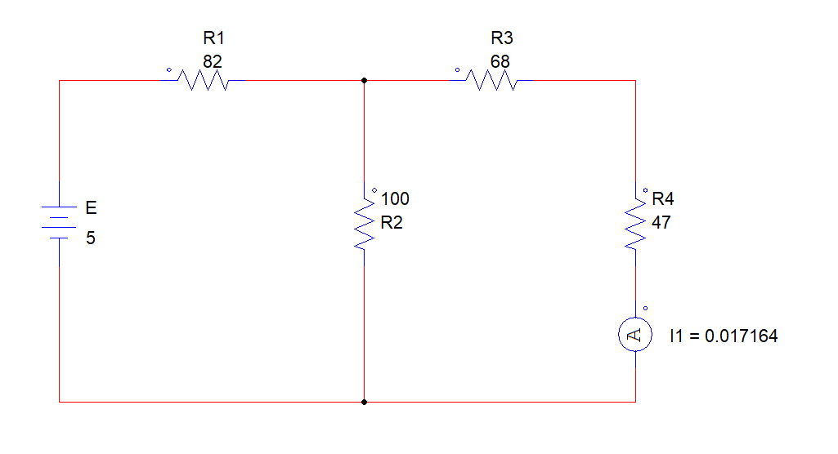
- I = 0.017164 A
Circuit 2 (A):
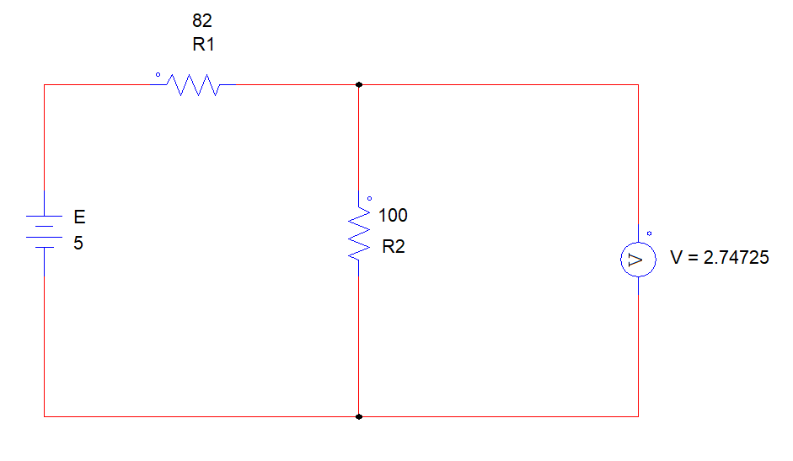
- Vth = 2.74725 V
Circuit A (3):
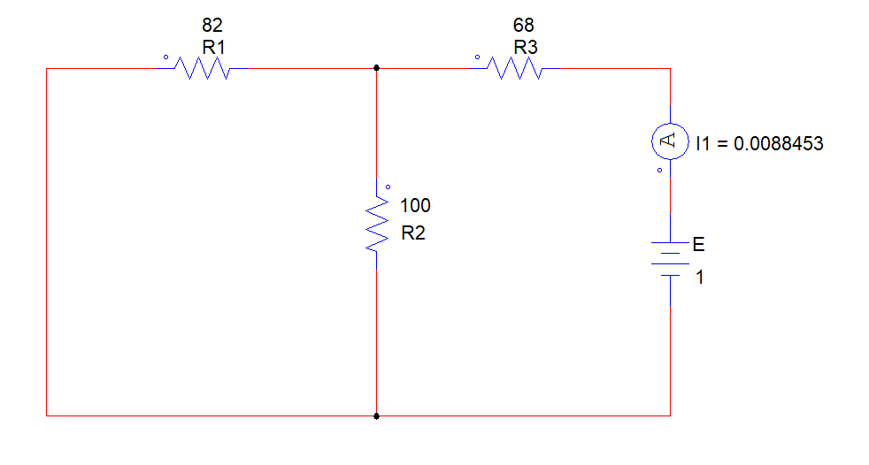
- Rth = 113.054390 Ohm’s
Circuit A (4):
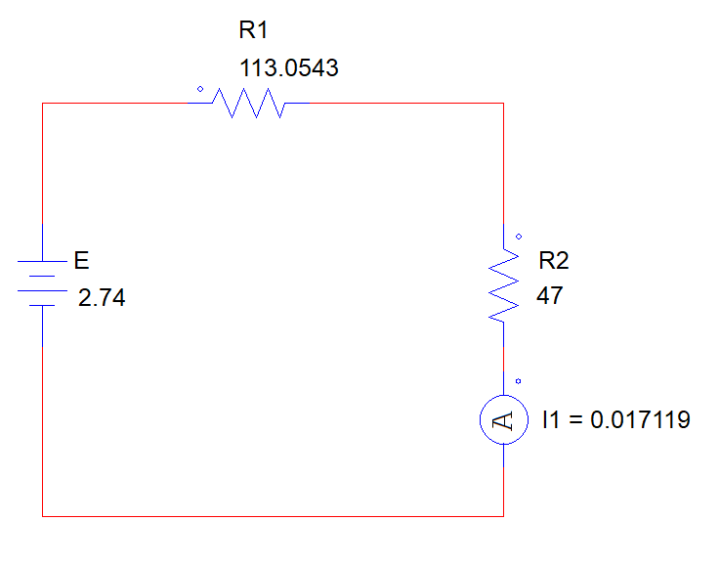
- I = 0.0171 A
Circuit B (1):
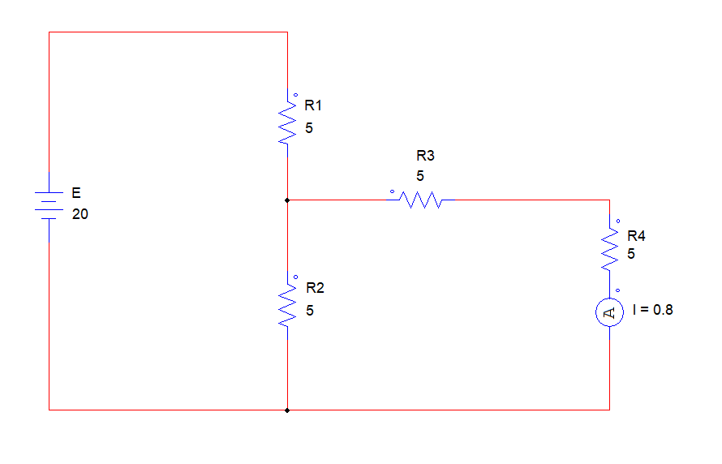
- I = 0.8 A
Circuit B (2):
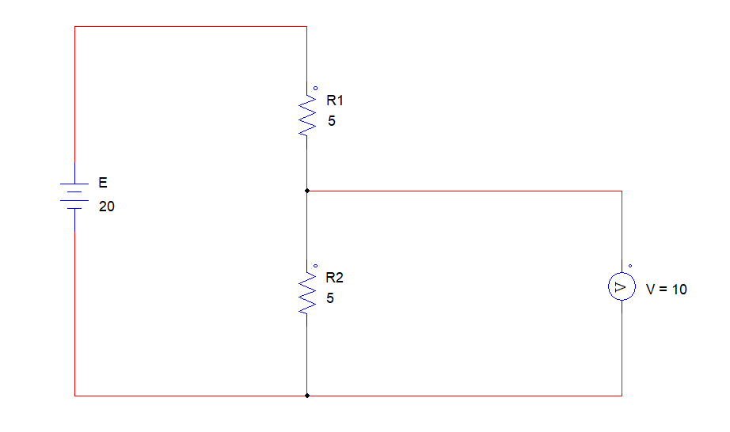
- Vth = 10 V
Circuit B (3):
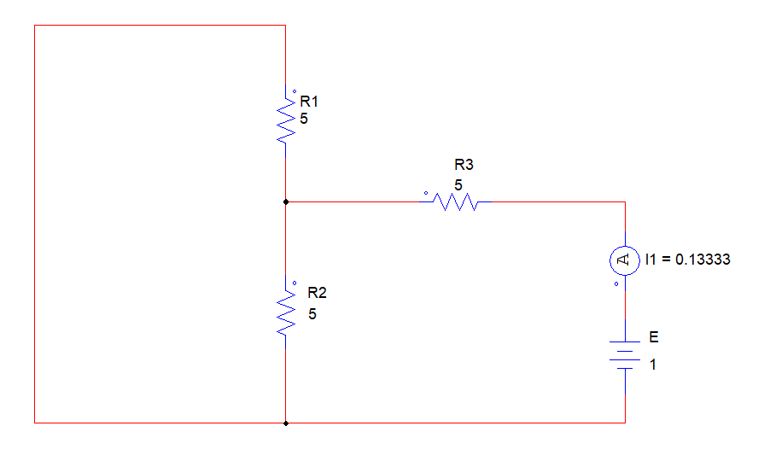
- Rth = 0.13333 A
Circuit B (4):
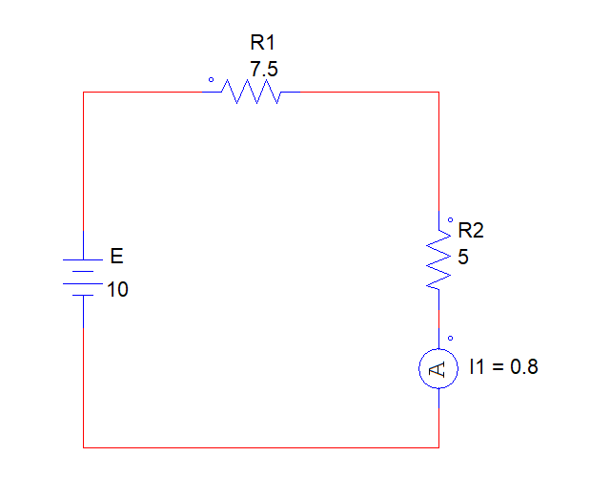
- I = 0.8 A
Data Table:
Circuit A:
I ( Circuit 1) | Vth (Circuit 2) | Rth (Circuit 3) | I (Circuit 4)
0.0171 A | 2.74725 V | 113.05439 Ohm’s | 0.0171 A

,’, Circuit A (1) and the Circuit A (4) match.
Circuit B:
I (Circuit 1) | Vth (Circuit 2) | Rth (Circuit 3) | I (Circuit 4)
0.8 A | 10 V | 7.50018 Ohm’s | 0.8 A

.’. Circuit B (1) and the Circuit B (4) match. Here we verified the Thevenin’s Theorem.
Discussion:
In this circuit, we have to measure the Vth and Rth. We have to calculate the equivalent resistance using the voltage and current. We evaluate the two circuits Circuit A and B using PSIM software. Compare the original and the Thevenin equivalent circuits current.

